Spearman rank correlation: USDCHF and EURGBP
Method 02 / daily log returns / Alpari D1 full available history

Study setup
Logical pair: USDCHF , EURGBP
Broker symbols: USDCHF_i , EURGBP_i
Snapshot: 2026-11-03_majors_alpari_D1
Timeframe: D1
Matched return window: 1999-01-06 to 2026-11-02 (UTC bar dates)
Matched return count n: 7182
Dropped unfinished last bar dated 2026-11-03 UTC after a tick-volume check against the prior complete day.
Complete matched rows (CSV): USDCHF-EURGBP_Spearman_D1.csv
Complete matched rows (HTML table): USDCHF-EURGBP_Spearman_D1_data.html

Method carried forward
Spearman rho is Pearson correlation on the ranks of matched daily log returns of close, ln(close_t / close_t-1), in the broker quote direction. Ties use average ranks. Quotes are not inverted. rho is symmetric under swap of the two symbols. rho = 0 means no consistent rank-order link in this sample; it does not mean no link of any kind. The score is not a cause, not a lead, and not a trading signal. Daily rows are not independent draws, so the two-sided p-value and approximate Fisher interval are reported and treated as secondary to rho. Same-sample Pearson r is shown only as a side check; a large rho minus r gap can flag outliers or a non-straight link.

Results
Spearman rho: -0.347712
Two-sided p-value: 3.33824e-203
Approximate 95% Fisher interval: [-0.367881, -0.327215]
Same-sample Pearson r: -0.325886
rho minus r: -0.021825

Conclusion
Over 7182 matched daily log-return rows for USDCHF and EURGBP (broker quote directions unchanged), Spearman rho is -0.3477 (negative, weak rank-order association in this sample). Approximate 95% Fisher interval: [-0.3679, -0.3272]. Same-sample Pearson r is -0.3259 (rho minus r = -0.0218). Two-sided p under the usual independent-ranks model is 3.338e-203; that model does not match linked daily FX returns, so treat p as secondary. This does not establish cause, lead-lag, or a lasting trading rule.

Charts
Daily closes

Daily log returns
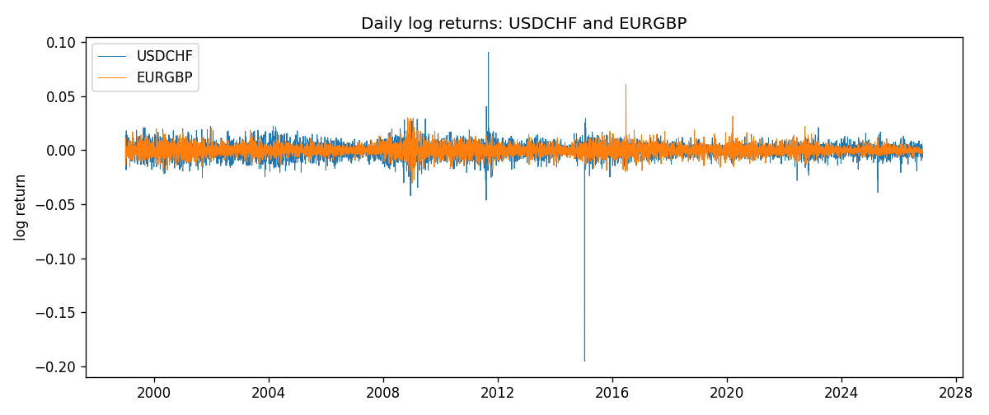
Log-return scatter
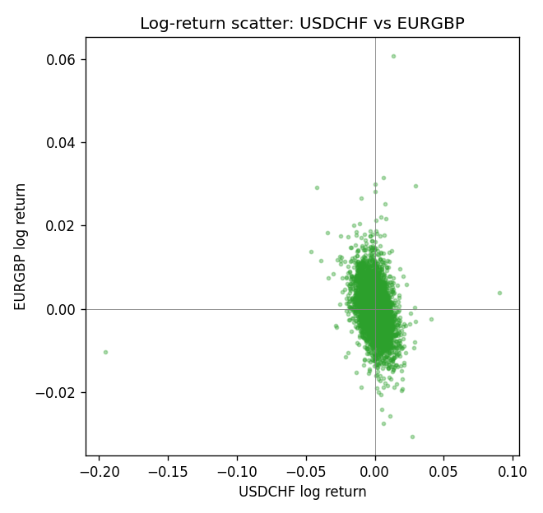
Rank-rank scatter
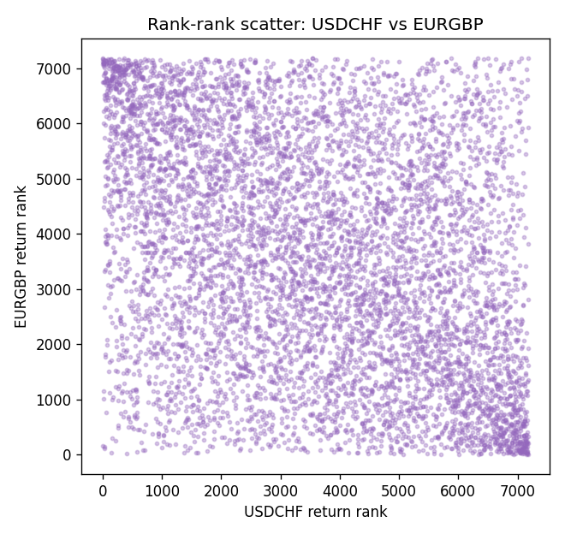

Data report
Every matched row that entered Spearman rho is stored in the sibling CSV named USDCHF-EURGBP_Spearman_D1.csv. That file is the complete data archive for redrawing charts. Embedding all rows as a Word table is impractical at this length; the Word file holds the column list, column summaries, and the first and last 15 matched rows.
Columns: time, USDCHF_open, EURGBP_open, USDCHF_high, EURGBP_high, USDCHF_low, EURGBP_low, USDCHF_close, EURGBP_close, USDCHF_tick_volume, EURGBP_tick_volume, USDCHF_spread, EURGBP_spread, USDCHF_real_volume, EURGBP_real_volume, USDCHF_log_return, EURGBP_log_return
Column summaries (matched calculation rows)
column | count | mean | std | min | 25% | 50% | 75% | max
USDCHF_open | 7182 | 1.0972493 | 0.25210985 | 0.72022 | 0.9204925 | 0.989875 | 1.237175 | 1.8219
EURGBP_open | 7182 | 0.7869939 | 0.09664695 | 0.5734 | 0.6877 | 0.833905 | 0.865225 | 0.9769
USDCHF_high | 7182 | 1.1025378 | 0.25385182 | 0.73305 | 0.924695 | 0.99351 | 1.242175 | 1.8313
EURGBP_high | 7182 | 0.79007306 | 0.09702085 | 0.5789 | 0.6897 | 0.836955 | 0.8681 | 0.9799
USDCHF_low | 7182 | 1.092133 | 0.25052689 | 0.08565 | 0.9171825 | 0.986205 | 1.2312 | 1.8121
EURGBP_low | 7182 | 0.7842938 | 0.09646529 | 0.5682 | 0.685725 | 0.83166 | 0.86287 | 0.9661
USDCHF_close | 7182 | 1.09724 | 0.25200902 | 0.72025 | 0.9207375 | 0.98991 | 1.23715 | 1.8217
EURGBP_close | 7182 | 0.78703952 | 0.09664503 | 0.5735 | 0.687825 | 0.83398 | 0.865375 | 0.977
USDCHF_tick_volume | 7182 | 74362.695 | 113509.88 | 18 | 12814.25 | 40258.5 | 70446 | 858589
EURGBP_tick_volume | 7182 | 87145.49 | 145506.26 | 154 | 6593.75 | 44371 | 81432 | 1424684
USDCHF_spread | 7182 | 26.020746 | 24.692144 | 0 | 5 | 16 | 50 | 100
EURGBP_spread | 7182 | 21.320663 | 19.117614 | 0 | 4 | 13 | 40 | 50
USDCHF_real_volume | 7182 | 2.3303821e+10 | 8.915094e+10 | 0 | 0 | 0 | 0 | 1.9331921e+12
EURGBP_real_volume | 7182 | 2.7876168e+10 | 1.3522356e+11 | 0 | 0 | 0 | 0 | 3.5726265e+12
USDCHF_log_return | 7182 | -7.199e-05 | 0.00659004 | -0.19545699 | -0.00335239 | 7.626e-05 | 0.00331734 | 0.09051364
EURGBP_log_return | 7182 | 2.529e-05 | 0.00487429 | -0.03067367 | -0.00262165 | -0.00010006 | 0.00256425 | 0.06075387
First 15 matched rows (selected columns)
time | USDCHF_close | EURGBP_close | USDCHF_log_return | EURGBP_log_return | USDCHF_tick_volume | EURGBP_tick_volume
1999-01-06 | 1.3912 | 0.7019 | 0.013605652 | -0.013303338 | 3740 | 2635
1999-01-07 | 1.3782 | 0.7097 | -0.0093883841 | 0.011051402 | 4262 | 2464
1999-01-08 | 1.3935 | 0.7062 | 0.011040268 | -0.004943862 | 5991 | 3132
1999-01-11 | 1.4009 | 0.7053 | 0.0052963193 | -0.0012752393 | 5236 | 2418
1999-01-12 | 1.3872 | 0.7077 | -0.0098275602 | 0.0033970309 | 5975 | 2670
1999-01-13 | 1.3621 | 0.708 | -0.018259701 | 0.00042381861 | 7036 | 2612
1999-01-14 | 1.3588 | 0.7066 | -0.0024256692 | -0.0019793588 | 5825 | 2560
1999-01-15 | 1.3834 | 0.7012 | 0.01794228 | -0.0076715819 | 7434 | 3031
1999-01-18 | 1.379 | 0.7017 | -0.0031856384 | 0.00071280921 | 4965 | 2461
1999-01-19 | 1.3789 | 0.7007 | -7.2518946e-05 | -0.0014261269 | 5494 | 2606
1999-01-20 | 1.3889 | 0.7021 | 0.0072259871 | 0.0019960086 | 5477 | 2341
1999-01-21 | 1.3836 | 0.7016 | -0.0038232689 | -0.00071240297 | 4736 | 2450
1999-01-22 | 1.3834 | 0.7004 | -0.0001445609 | -0.0017118406 | 4833 | 2600
1999-01-25 | 1.3868 | 0.6966 | 0.0024546976 | -0.0054402425 | 3996 | 2304
1999-01-26 | 1.3897 | 0.6962 | 0.0020889617 | -0.00057438255 | 5399 | 3025
Last 15 matched rows (selected columns)
time | USDCHF_close | EURGBP_close | USDCHF_log_return | EURGBP_log_return | USDCHF_tick_volume | EURGBP_tick_volume
2026-10-13 | 0.83244 | 0.84458 | -0.0024955621 | 0.00020130374 | 32763 | 30915
2026-10-14 | 0.83489 | 0.84553 | 0.0029388325 | 0.0011241873 | 40903 | 39105
2026-10-15 | 0.82676 | 0.84479 | -0.0097855323 | -0.00087557391 | 54132 | 45290
2026-10-16 | 0.82377 | 0.84307 | -0.0036230826 | -0.0020380844 | 47176 | 39309
2026-10-19 | 0.82677 | 0.84259 | 0.0036351779 | -0.00056950988 | 40610 | 38133
2026-10-20 | 0.8246 | 0.83957 | -0.0026281224 | -0.0035906254 | 42106 | 42542
2026-10-21 | 0.82427 | 0.83839 | -0.00040027413 | -0.00140647 | 37648 | 35843
2026-10-22 | 0.82032 | 0.83682 | -0.0048036381 | -0.0018743924 | 50809 | 44479
2026-10-23 | 0.82497 | 0.83751 | 0.005652514 | 0.00082421033 | 45872 | 37399
2026-10-26 | 0.82649 | 0.83762 | 0.0018407959 | 0.00013133309 | 41336 | 38735
2026-10-27 | 0.82865 | 0.83595 | 0.0026100526 | -0.0019957343 | 35560 | 36303
2026-10-28 | 0.82781 | 0.83651 | -0.0010142111 | 0.00066967224 | 42431 | 36532
2026-10-29 | 0.82379 | 0.83553 | -0.0048680164 | -0.0011722209 | 53780 | 49261
2026-10-30 | 0.82438 | 0.83351 | 0.00071594559 | -0.0024205543 | 55459 | 44060
2026-11-02 | 0.81851 | 0.83426 | -0.0071459744 | 0.00089940465 | 45329 | 43437

